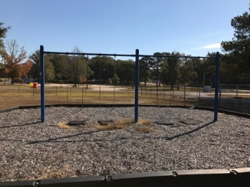 Swing Set ______________ 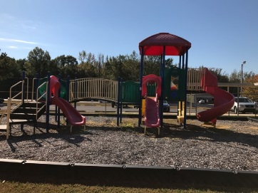 Play Station ___________

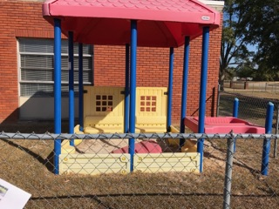 Sandbox ________________ 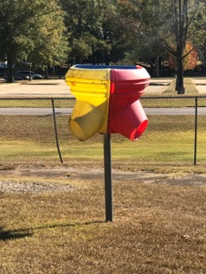 Ball Tunnel _______________

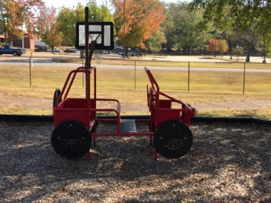 Stationary Car ____________ 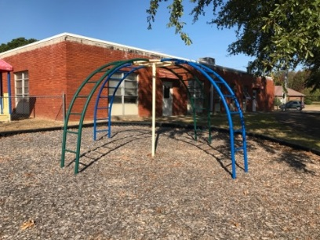 Jungle Gym ___________

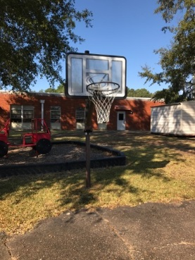 Basketball Goal _____________ 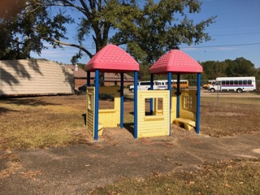 Play Fort _____________